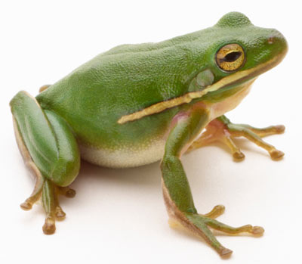
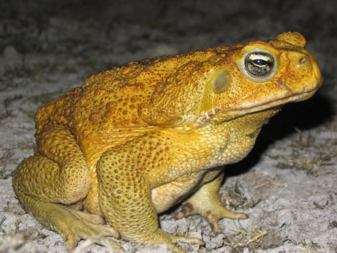
R the young live in water
L bulging eyes
F walk
Q have teeth in top jaw
K lay eggs in chains
E jump
P have no teeth
J lay eggs in clusters
D the young have gills
O poison glands behind eyes
I slimy, smooth skin
C adults have lungs
N have a heart
H dry, warty skin
B have a back bone
M hatch from an egg
G have a brain
A are amphibians
Frogs
Toads

